Project Synopsis

on

Sign Language Recognition System

Submitted as a part of course curriculum for

# Bachelor of Technology

in

# Computer Science



**Submitted by :**

Vidhi 2000290120188

Vishakha Rana 2000290120192

Sanskriti 2000290120135

**Under the Supervision of** Mr. Raj kumar

(Assistant Professor)

# KIET Group of Institutions, Ghaziabad Department of Computer Science

**Dr. A. P. J. Abdul Kalam Technical University**

**2022-2023**

# DECLARATION

We hereby declare that this submission is our work and that, to the best of our knowledge and belief, it contains no material previously published or written by another person nor material which to a substantial extent has been accepted for the award of any other degree or diploma of the university or other institute of higher learning, except where due acknowledgement has been made in the text.

Signature

Name: Vidhi

Rollno :2000290120188

Name: Vishakha Rana Rollno :2000290120192

Name: Sankriti

Rollno :2000290120146

Date : 14/11/2022

# CERTIFICATE

This is to certify that Project Report entitled “**Sign Language Recognition System**” which is submitted by **Vidhi, Vishakha Rana, Sanskriti** in partial fulfilment of the requirement for the award of degree B. Tech. in Department of Computer Science of Dr A.P.J. Abdul Kalam Technical University, Lucknow is a record of the candidates own work carried out by them under my supervision. The matter embodied in this report is original and has not been submitted for the award of any other degree.

**Date : 14/11/2022**

**Supervisor Signature**

Mr. Raj kumar

(Assistant Professor)

# ACKNOWLEDGEMENT

It gives us a great sense of pleasure to present the synopsis of the Sign Language Recognition System undertaken during B.Tech. Third Year. We owe a special debt of gratitude to **Mr. Raj kumar**, Department of Computer Science, KIET Group of Institutions, Delhi- NCR, Ghaziabad, for his/her constant support and guidance throughout the course of our work. **His** sincerity, thoroughness and perseverance have been a constant source of inspiration for us. It is only his/her cognizant efforts that our endeavours have seen the light of the day.

We also take the opportunity to acknowledge the contribution of **Dr. Ajay Kumar Shrivastava**, Head of the Department of Computer Science, KIET Group of Institutions, Delhi- NCR, Ghaziabad, for his full support and assistance during the development of the project. We also do not like to miss the opportunity to acknowledge the contribution of all the faculty members of the department for their kind assistance and cooperation during the development of our project.

Last but not the least, we acknowledge our friends for their contribution to the completion of the project.

Signature:

Date : 14/11/2022

Names : Vidhi -2000290120188

Vishakha Rana 2000290120192

Sanskriti Bajpai 2000290120135

# ABSTRACT

# Every day we see many people who are have disabilities like being deaf, dumb, blind etc. They face difficulty to interact with others.

# Sign language is the only tool of communication for the person who is not able to speak or hear anything. Sign language is a boon for the physically challenged people to express their thoughts and emotion. In this work, a novel scheme of sign language recognitionhas been proposed for identifying the alphabets and gestures in sign language. With the help of computer vision and neural networks we can detect the signs and give the respective text output.

# Previously developed techniques are all sensors based and they didn’t give the general solution. Now technology is developed to the point that AI can help to solve this problem. The proposed system would be a real time system wherein live sign gestures would be processed using image processing and then converted into speech. Machine Learning algorithms will be used to train on the data set. The purpose of the system is to improve the existing system in this area in terms of response time and accuracy with the use of efficient algorithms, high quality data sets and better sensors. The existing systems have been able to recognize gestures with high latency as it uses only image processing. In our project we aim to develop a cognitive system which would be responsive and robust so as to be used in day to day applications by hearing and speech disabled people.

# INTRODUCTION

Sign Language is a form of communication used primarily by people hard of hearing or deaf. This type of gesture-based language allows people to convey ideas and thoughts easily overcoming the barriers caused by difficulties from hearing issues.

A major issue with this convenient form of communication is the lack of knowledge of the language for the vast majority of the global population. Just as any other language, learning Sign Language takes much time and effort, discouraging to from being learned by the larger population.

However, an evident solution to this issue is present in the world of Machine Learning and Image Detection. Implementing predictive model technology to automatically classify Sign Language symbols can be used to create a form of real-time captioning for virtual conferences like Zoom meetings and other such things. This would greatly increase access of such services to those with hearing impairments as it would go hand-in-hand with voice-based captioning, creating a two-way communication system online for people with hearing issue

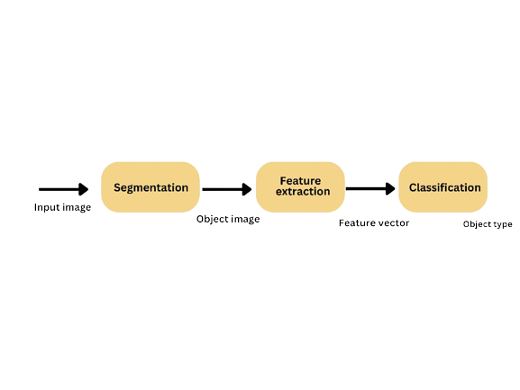

# Fig.1 System overview

# PROBLEM STATEMENT

# Speech impaired people use hand signs and gestures to communicate. Normal people face difficulty in understanding their language as they don’t recognize the sign made by them ,this make a barrier.

# Hence there is a need of a system which recognizes the different signs, gestures and conveys the information to the normal people. It bridges the gap between physically challenged people and normal people.

# Sign language uses lots of gestures so that it looks like movement language which consists of a series of hands and arms motions. For different countries, there are different sign languages and hand gestures. Also, itis noted that some unknown words are translated by simply showing gestures for each alphabet in the word. In addition, sign language also includes specific gestures to each alphabet in the English dictionary and for each number between 0 and 9. Based on these sign languages are made up of two groups, namely static gesture, and dynamic gesture. The static gesture is used for alphabet and number representation, whereas the dynamic gesture is used for specific concepts. Dynamic also includes words, sentences, etc. The static gesture consists of hand gestures, whereas the latter includes motion of hands, head, or both. Sign language is a visual language and consists of 3 major components, such as finger-spelling, word-level sign vocabulary, and non-manual features. Finger-spelling is used to spell words letter by letter and convey the message whereas the latter is keyword-based. But the design of a sign language translator is quite challenging despite many research efforts during the last few decades. Also, even the same signs have significantly different appearances for different signers and different viewpoints. This work focuses on the creation of a static sign language translator by using a Convolutional Neural Network. We created a lightweight network that can be used with embedded devices/standalone applications/web applications having fewer resources.

# OBJECTIVE

* We aim to build a system virtual talking system without sensor for people who in need, this concept achieving a by using image processing and human hand gesture input. This mainly helps to people who can’t talk with other people.
* In the proposed system enable the speech impaired person should provide a gesture or sign image to the system. The system evaluates the sign input with image processing technique and classifies the input to the recognized identification. Later it initiates the voice media through the system when the input image matches with the given dataset. And the output will be shown in the text format too. This is a prototype to develop the concept of converting the sign language to speech and text.
* The main objectives of this project are to contribute to the field of automatic sign language recognition and translation to text or speech. In our project, we focus on static sign language hand gestures.
* This work focused on recognizing the hand gestures which includes 26 English alphabets (A-Z) and 10 digits (0-9) using Deep Neural Networks (DNN). We created a convolution neural networks classifier that can classify the hand gestures into English alphabets and digits.
* We have trained the neural network under different configurations and architectures like LeNet-5 , MobileNetV2 , and our own architecture. We used the horizontal voting ensemble technique to achieve the maximum accuracy of the model. We have also created a web application using Django Rest Frameworks to test our results from a live camera.

# SCOPE

The main purpose of sign language recognition system is to make speech impaired people normal life And being able to communicate like every normal person..

The proposed sign language recognition system used to recognize sign language letters can be further extended to recognize gestures facial expressions. Instead of displaying letter labels it will be more appropriate to display sentences as more appropriate translation of language. This also increases readability.The scope of different sign languages can be increased.

# LITERATURE REVIEW

The classifcation of diferent comparison parameters used in this review is shown in Fig. 8. The strategy that we have followed for Systematic Literature Review includes acquisition mode, static/dynamic signs, signing mode, single/ double handed signs, techniques used and average accuracy as their parameters. On the basis of these parameters, the review for diferent sign languages like American Sign Language (ASL), Indian Sign Language (ISL), Arabic Sign Language (ArSL), Chinese Sign Language (CSL), Persian, Brazilian, Greek, Irish, Malaysian, Mexican, Taiwanese, Thai, German, Japanese, South African, Sri Lankan, Auslan, Bangladeshi, Ecuadorian, Ethiopian, Farsi, Italian, Polish, Spanish and Ukrainian Sign Languages have been analyzed and documented respectively[7]

A Review on Feature Extraction for Indian and American Sign Language in [8]: Paper presented the recent research and development of sign language based on manual communication and body language. Sign language recognition system typically elaborate three steps preprocessing, feature extraction and classification. Classification methods used for recognition are Neural Network (NN), Support Vector Machine (SVM), Hidden Markov Models (HMM), Scale Invariant Feature Transform (SIFT), etc

# PROPOSED METHODOLOGY

# Supervised machine learning:It is one of the ways of machine learning where the model is trained by input data and expected output data. CNN is part of it,

# Convolutional Neural Networks (CNNs) are machine learning algorithms that have seen a great success as it handles a variety of tasks related to processing videos and images. Like other machine learning algorithms, CNNs seek to optimize some objective function, specifically the loss function. CNNs have seen a rapid improvement in image classification with many proposed models like GoogleNet, AlexNet giving an accuracy almost near to human perception. The main cause of the recent improvement in CNNs has been due to the ImageNet Large Scale Visual Recognition Competition(ILSVRC). For image processing we propose to use OpenCV library along with TensorFlow and Keras which will be used for training the classifier. For other mathematical calculations we may use the NumPy Array in Python . The various approaches we considered are explained in the subsequent paragraphs.

# 

# Fig.2 . Architecture of vision-based sign language recognition.

# Algorithm Proposed

Classification machine learning algorithms like SVM, k-NN are used for supervised learning, which involves labeling the dataset before feeding it into the algorithm for training. For this project, various classification algorithms are used: SVM, k-NN and CNN.

Feature extraction algorithms are used for dimensionality reduction to create a subset of the initial features such that only important data is passed to the algorithm. When the input to the algorithm is too large to be processed and is suspected to be redundant (like repetitiveness of images presented by pixels), then it can be converted into a reduced set of features. Feature extraction algorithms: PCA, LBP, and HoG, are used alongside classification algorithms for this purpose. This reduces the memory required and increases the efficiency of the model.

Histogram of Oriented Gradients (HOG) The histogram of oriented gradients (HOG) is a feature descriptor used in computer vision and image processing for the purpose of object detection. The technique counts occurrences of gradient orientation in localized portions of an image. This method is similar to that of edge orientation histogram but differ in that it is computed on a dense grid of uniformly spaced cells and uses overlapping local contrast normalization or improved accuracy. The use of HOG is that local object appearance are sharp within an image can be described by distribution of intensity gradient or edge direction. The image is divided into small connected region called cells and for the pixels within each cells a histogram of gradient direction is compiled.

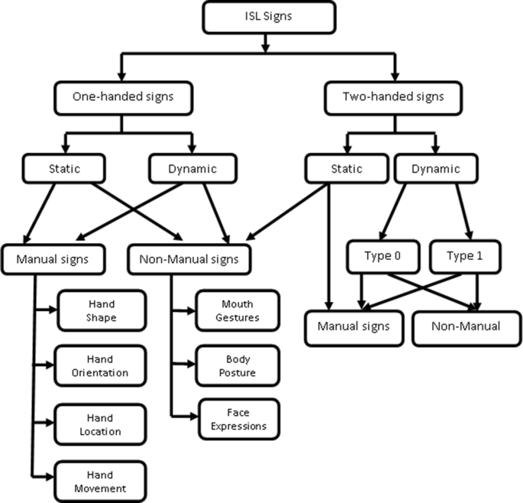

Fig. 3. Hierarchy of signs [3]

# 

# Fig.4 . Sign Language Recognition System Architecture

# TECHNOLOGIES USED

* IMAGE RECOGNITION
* OPENCV
* NUMPY
* KERAS

# DIAGRAMS

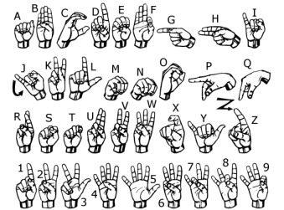

**FIG.5. SIGN LANGUAGE HAND GESTURES**

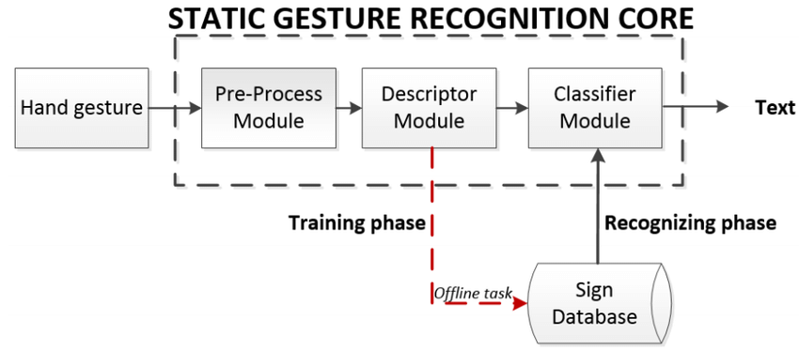

# Fig.6 . Sign language recognition flow chart

**EXPECTED OUTCOME**

The sensor less sign language and gesture recognition system is a module which provides an easy and satisfactory user communication for deaf and dumb people. The module provides two way communications which helps in easy interaction between the normal people and disables. The system is novel approach to ease the difficulty in communicating with those having speech and vocal disabilities. The aim is to provide an application to the society to establish the ease of communication between the deaf and mute people by making use of image processing algorithm. Since it follows an image based approach it can be launched as an application in any minimal system and hence has near zero-cost..

# REFERENCES

1. **https://www.ijert.org/a-review-paper-on-sign-language-recognition-for-the-deaf-and-dumb**
2. [**http://vision.stanford.edu/teaching/cs231a_autumn1213_internal/project/final/writeup/distributable/Chen_Paper.pdf**](http://vision.stanford.edu/teaching/cs231a_autumn1213_internal/project/final/writeup/distributable/Chen_Paper.pdf)
3. **https://research.ijais.org/icwac/number2/icwac1320.pdf**
4. [**https://ijrpr.com/uploads/V2ISSUE9/IJRPR1329.pdf**](https://ijrpr.com/uploads/V2ISSUE9/IJRPR1329.pdf)
5. [**https://www.researchgate.net/publication/262187093_Sign_language_recognition_State_of_the_ar**](https://www.researchgate.net/publication/262187093_Sign_language_recognition_State_of_the_ar)
6. <https://sci-hub.se/https://ieeexplore.ieee.org/document/726791>
7. [**https://www.researchgate.net/publication/337990440_Sign_Language_Recognition_Systems_A_Decade_Systematic_Literature_Review**](https://www.researchgate.net/publication/337990440_Sign_Language_Recognition_Systems_A_Decade_Systematic_Literature_Review)
8. **https://www.irjet.net/archives/V7/i3/IRJET-V7I3418.pdf**